**Name: Srijan Tamang**

**L5CG24**

**Q.1. Find the sum of numbers from 1 to 10.**

#include <stdio.h>

int main(){

int sum = 0;

for (int i = 1; i<=10; i++){

sum += i;

}

printf("The sum of number from 1 to 10 is: %d\n", sum);

return 0;

}

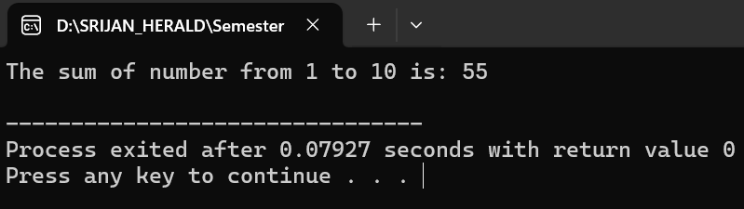

**Q.2. Find the factorial of a number**

#include <stdio.h>

int main(){

int num, factorial = 1;

printf("Enter a positive integer: ");

scanf("%d",&num);

for (int i = 1; i<=num; i++){

factorial *= i;

}

printf("The factorial of %d is: %d\n",num,factorial);

return 0;

}

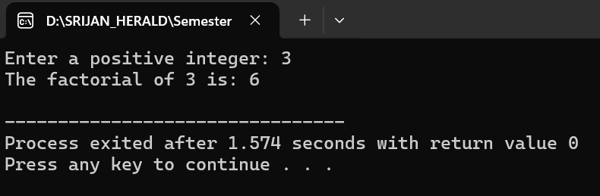

**Q3. Print all triangular numbers from 1 up to nth term.**

#include <stdio.h>

int printTriangularNumber(int n){

for (int i = 1; i<=n; i++){

int triangularNumber = i * (i+2) / 2;

printf("%d",triangularNumber);

}

printf("\n");

}

int main(){

int n;

printf("Enter the number of terms: ");

scanf("%d",&n);

if (n>0){

printf("Triangular numbers upto %dth term:\n",n);

printTriangularNumber(n);

}else{

printf("Please enter a positive integer.\n");

}

return 0;

}

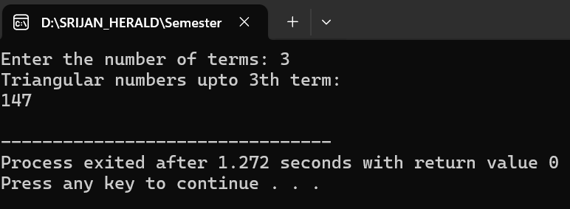

**Q4.** **Input a character and print it in lowercase.**

#include <stdio.h>

int main(){

char ch;

printf("Enter a character: ");

scanf(" %c",&ch);

if(ch>= 'A' && ch<='Z'){

ch = ch + ('a' - 'A');

}

printf("The lowercase character is: %c",ch);

return 0;

}

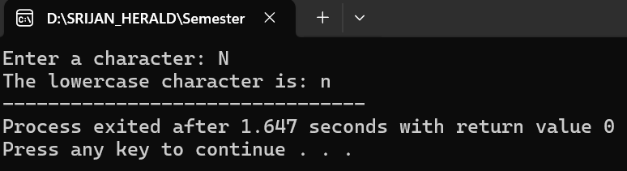

**Q.5. Input characters until Enter is pressed**

#include <stdio.h>

int main(){

char ch;

printf("Enter characters (press Enter to stop):\n");

while((ch = getchar()) != '\n'){

if (ch >= 'A' && ch<='Z'){

ch = ch + ('a' - 'A');

}

printf("%c\n",ch);

}

return 0;

}

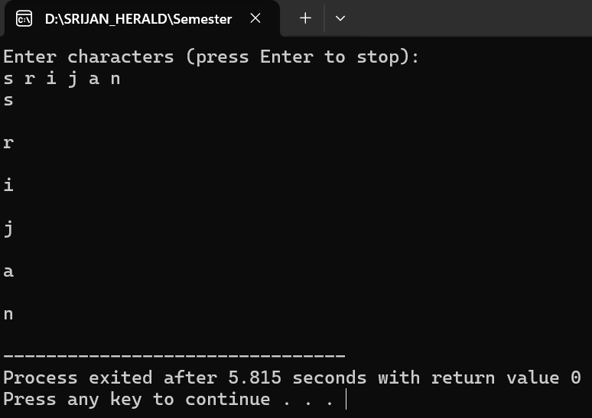

**Q.6. Print the pattern using nested loops.**

#include <stdio.h>

int printTriangularNumber(int n){

for (int i = 1; i<=n; i++){

int triangularNumber = i * (i+2) / 2;

printf("%d",triangularNumber);

}

printf("\n");

}

int main(){

int n;

printf("Enter the number of terms: ");

scanf("%d",&n);

if (n>0){

printf("Triangular numbers upto %dth term:\n",n);

printTriangularNumber(n);

}else{

printf("Please enter a positive integer.\n");

}

return 0;

}

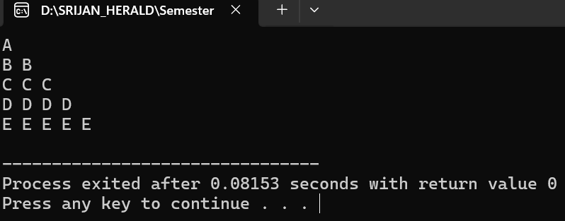

Thank You!